**Ivana Jones**

* IBM Data Engineering Fundamentals

* Rice University Introduction to Scripting in Python

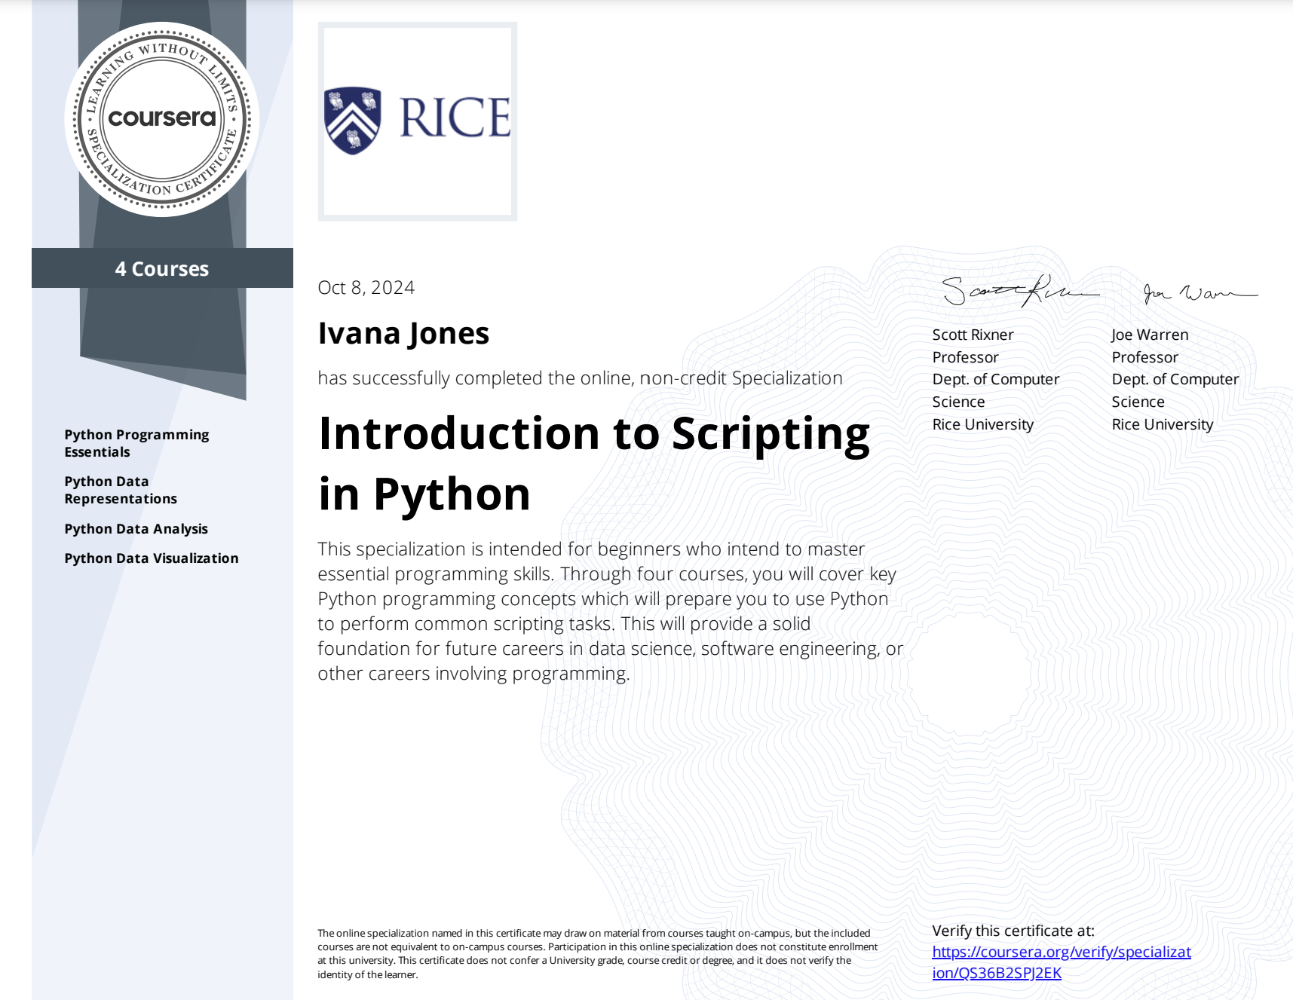

* Google Business Intelligence Professional Certificate (Data models, ETL Pipelines, and Dashboards)

* Rice University Leadership Development
* Alteryx Certified: Alteryx Designer Core Certification

* Microsoft Power Platform
* A screenshot of a certificate

  Description automatically generated
* PCED
* CSSC: Lean Six Sigma Green Belt

